**CANTERBURY CRICKET ASSOCIATION 1953-54**

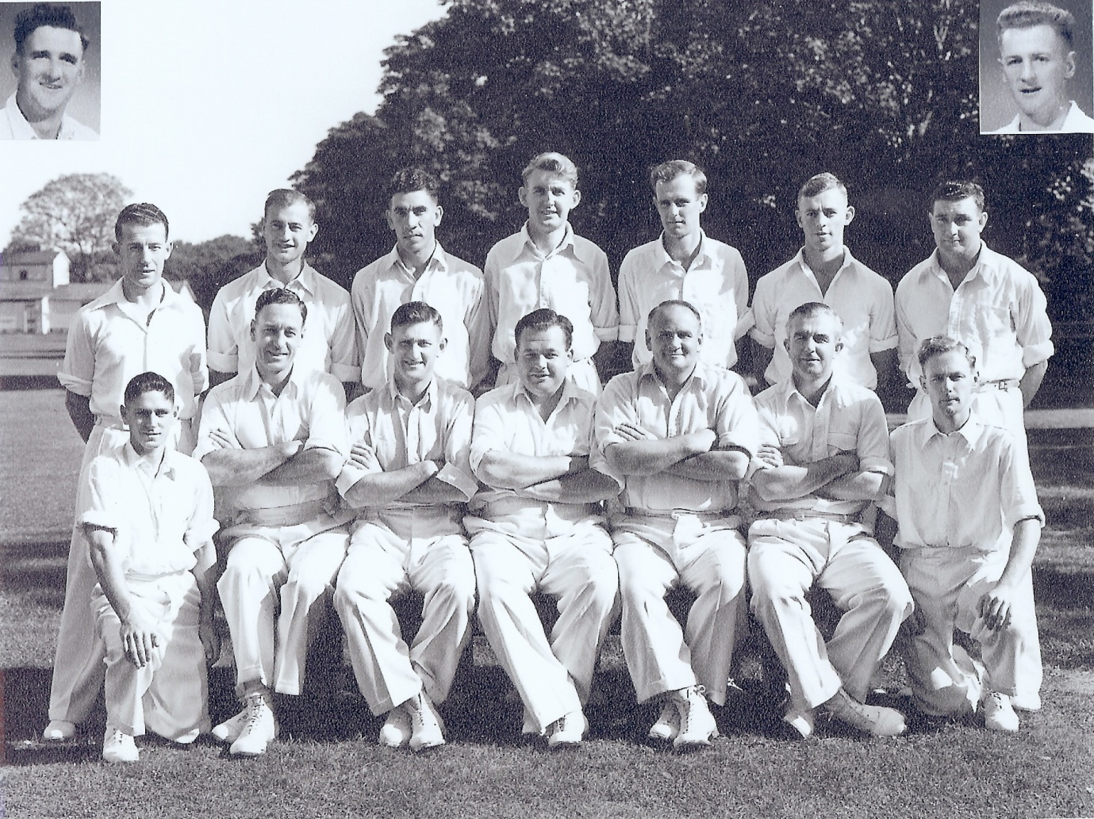

**Back row:** RT Dowker, PGZ Harris, SC Guillen, DJ Reid, D Stark, I Sinclair, GN Gearry

**Front row:** BA Haworth, RH Scott, JA Hayes, JG Leggat (captain), TB Burtt, RWG Emery,

GE Royfee

**Inset:** PW O’Malley, P Arnold